**NAME:** WACHSIRIN SARAYUTPISAI **STUDENT ID:** 1640700223

# Group: CoolCats

# Hades

# 

Hades is a god-like rogue-like dungeon crawler that combines the best aspects of Supergiant's critically acclaimed titles, including the fast-paced action of Bastion, the rich atmosphere and depth of Transistor, and the character-driven storytelling of Pyre.

Credit: <https://store.steampowered.com/app/1145360/Hades/?l=thai>

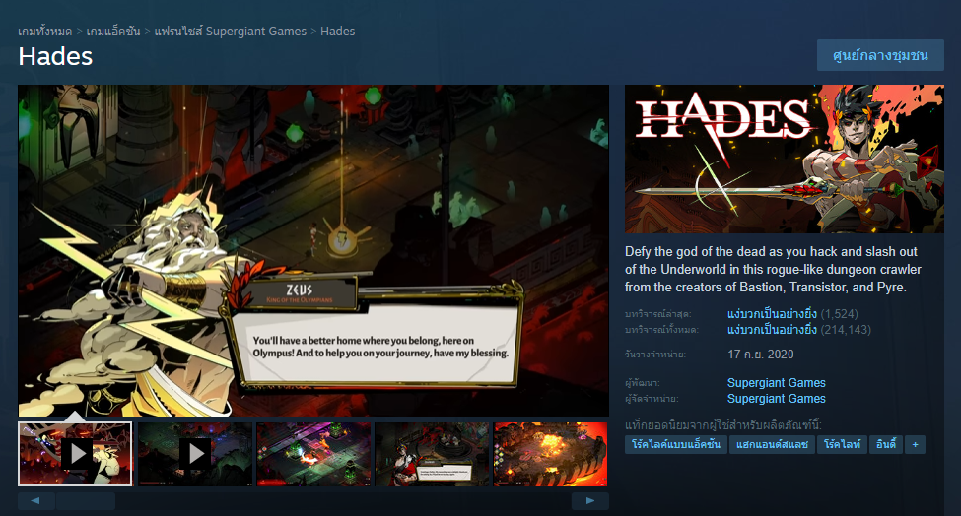

# Aesthetics

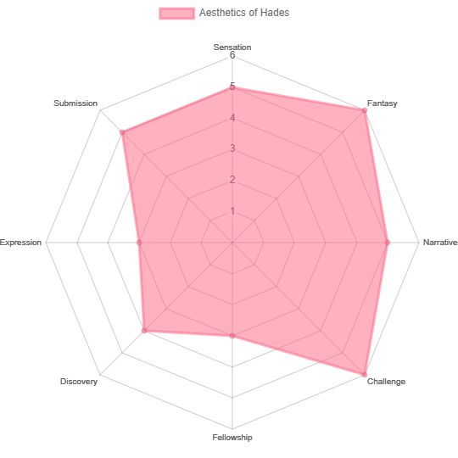

* Sensation: 5 Points (The game has images and sounds that go together very well and gives a very juicy feel, but gave it a 5 because I think the images should convey a little more violence.)
* Fantasy: 6 Points (Everything in the game is very fantasy, both the story and characters, including the visuals and sound work, it is truly a fantasy game.)
* Narrative: 5 Points (The characters and the world are all on the same theme.)
* Challenge: 6 Points (Monsters and bosses often have unique combat mechanics that keep them challenging.)
* Fellowship: 3 Points (The game only has a leaderboard, can't play together.)
* Discovery: 4 Points (Even though players are constantly encountering new things, Overall there isn't much difference.)
* Expression: 3 Points (The game has a few types of weapons, so our character is not much different from other players.)
* Submission: 5 Points (Hades is a game that requires a lot of concentration, so it takes a long time to play continuously to complete each level.)

# Loop: Unlocking new Weapons

[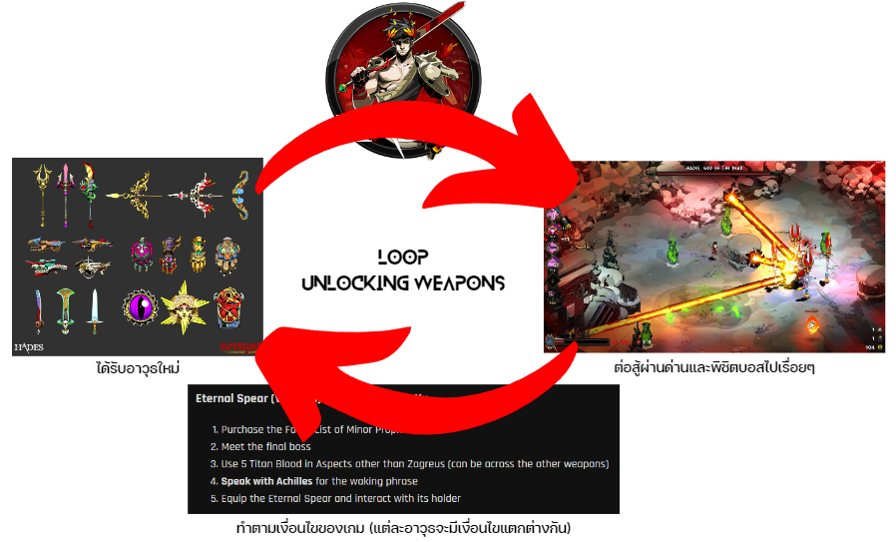](https://www.shacknews.com/article/121824/how-to-unlock-hidden-aspects-hades)

Figure 1https://www.shacknews.com/article/121824/how-to-unlock-hidden-aspects-hades

# Loop: Character Enhancement

# 

# Tangible Elements

* CCC (Character, Camera, Control):
  + Character: Players take on the role of Zagreus, the son of Hades, with the goal of escaping the underworld in search of his mother.
  + Camera: The game uses an isometric camera perspective.
  + Control: Movement is achieved using the WASD keys, and players can click the mouse to attack/defend, with abilities changing based on the weapon equipped.
* Space Time: Being in the underworld, the exact passage of time is unknown.
* Objects Attributes States: This includes weapons and Boons (special abilities granted by gods)
* Action and Rules: Before embarking on a journey, players must choose the most suitable weapon and utilize combat skills to handle various situations. If they die, they must start from the beginning.
* Skill and Chances: During the journey, players gain special abilities from gods and lose them upon death. However, players can also use points acquired from leveling up their status to make their character stronger.